Mini Server

💾 What is a Mini Server?
# Source: AI Source: Provided by: [Data Path: Persons Table -> ID Column: 1, Name_En Column: Motasem Essam] -> From: [ChatGPT] on [1/16/2026]
A Mini Server is a compact, space-saving server that offers basic server functions — such as file sharing, media hosting, web serving, or backups — in a small, low-power form factor.
📌 It's like a "mini PC" but designed to act as a server — ideal for home labs, personal clouds, or small offices.

Mini Server images
# Source: ScreenShot Source: Provided by: [Persons Table -> ID Column: 1, Name_En Column: Motasem Essam] -> Tool: [Lightshot Program] -> From [Site: Google Search: Images: mini server] on [1/16/2026]
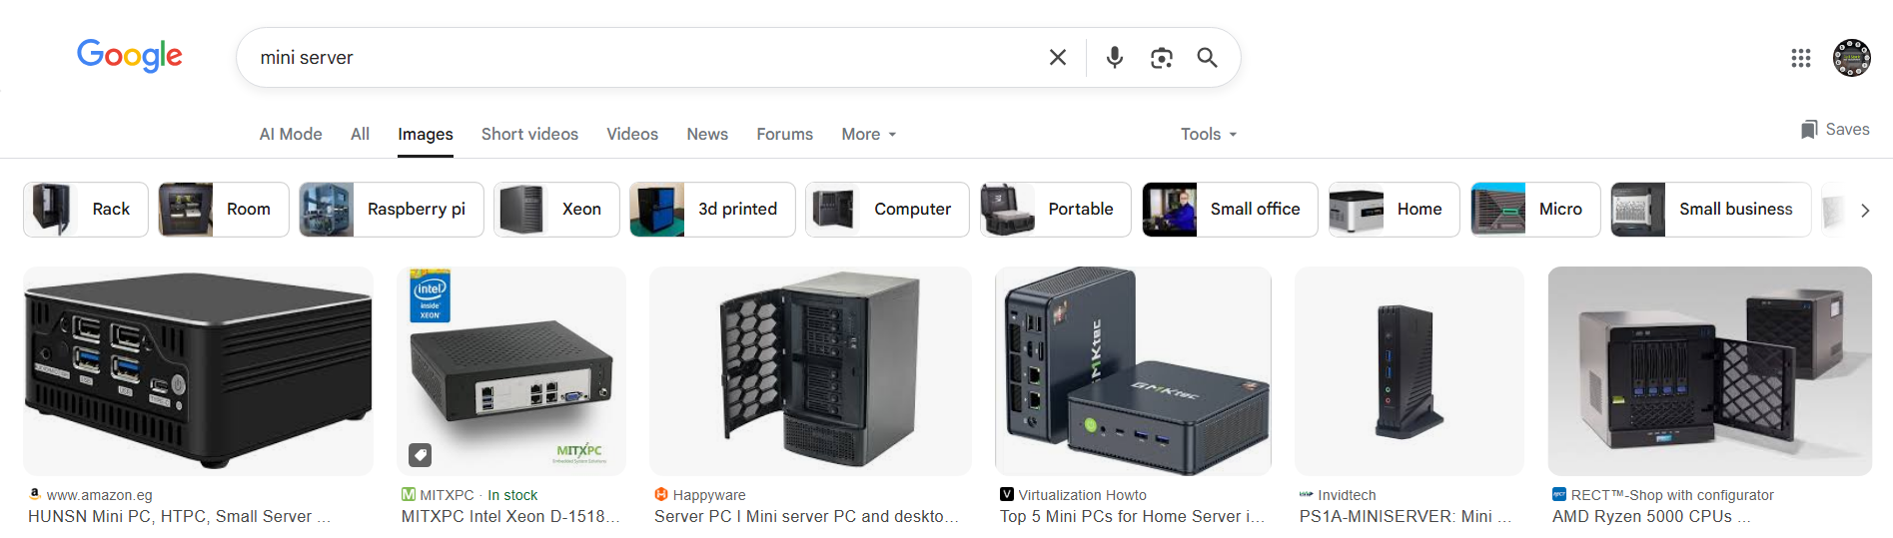

🧠 Key Characteristics
# Source: AI Source: Provided by: [Data Path: Persons Table -> ID Column: 1, Name_En Column: Motasem Essam] -> From: [ChatGPT] on [1/16/2026]
Feature | Description
📏 Small Size | Fits in your hand or on a shelf (like a mini desktop)
⚡ Low Power Use | Uses little energy — can run 24/7 with minimal electricity
🧊 Quiet Operation | Often fanless or silent (some use SSDs or passive cooling)
🛠️ Simple Setup | Plug, connect to network, and configure — no rack or data center needed
🧰 Versatile | Can act as NAS, web server, DNS server, VPN, media server, etc.

✅ Common Examples of Mini Servers
# Source: AI Source: Provided by: [Data Path: Persons Table -> ID Column: 1, Name_En Column: Motasem Essam] -> From: [ChatGPT] on [1/16/2026]
Model | Use Case | Notes
Raspberry Pi (4/5) | Personal web/NAS server | Very cheap, Linux-based
Intel NUC | Small office server | Compact x86 mini PC
Synology/QNAP NAS | File/media server | With built-in storage + apps
HP MicroServer Gen10 Plus | Entry-level business server | Reliable, affordable, server-grade

🔄 Mini Server vs Other Servers
# Source: AI Source: Provided by: [Data Path: Persons Table -> ID Column: 1, Name_En Column: Motasem Essam] -> From: [ChatGPT] on [1/16/2026]
Feature | 🧊 Mini Server | 🧱 Tower Server | 📦 Rack Server
💡 Size | Very small / portable | Medium (desktop-size) | Flat, wide (for rack use)
⚡ Power | Very low | Moderate | Higher
🔧 Expandability | Limited (RAM, SSD only) | More slots & bays | Hot-swappable parts
💰 Cost | 💲 Very low to moderate | 💲 Moderate | 💲💲💲 Higher
🧑‍💼 Use Case | Home, labs, media server | Office, backups | Enterprise/data center use

🧰 What Can You Do with a Mini Server?
# Source: AI Source: Provided by: [Data Path: Persons Table -> ID Column: 1, Name_En Column: Motasem Essam] -> From: [ChatGPT] on [1/16/2026]

Role | Example Tools
🗃️ File server | Samba, TrueNAS, Syncthing
🌐 Web server | Apache, Nginx, PHP
📺 Media server | Plex, Jellyfin, Emby
🔒 VPN server | OpenVPN, WireGuard
📦 Container host | Docker, Portainer
🧪 Dev/test environment | Linux, LAMP, Node.js

✅ Summary
# Source: AI Source: Provided by: [Data Path: Persons Table -> ID Column: 1, Name_En Column: Motasem Essam] -> From: [ChatGPT] on [1/16/2026]

Property | Value
What is it? | A tiny server for light to medium tasks
Who uses it? | Developers, home users, labs, small offices
Why use it? | Affordable, quiet, energy-efficient
Best for | NAS, media, web, VPN, automation

